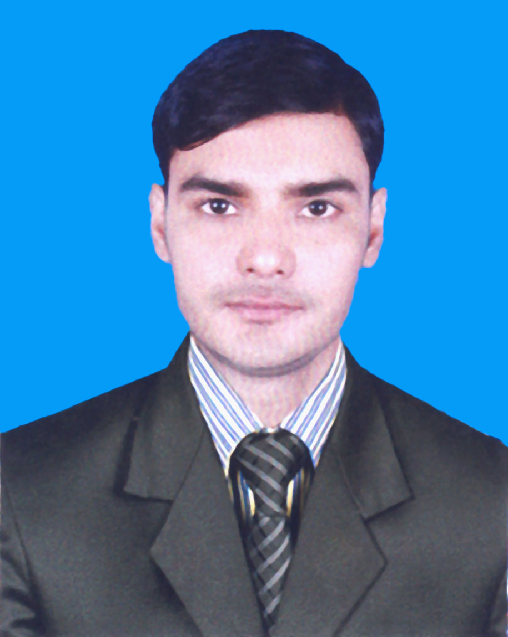
Resume
Of
MD. SHAWON SAIKAT

Permanent address

C/O-Md. Fazlul Haque
Vill: Fakirabad, P.O: Golapnagar
P.S: Bheramara, Dist: Kushtia
Cell: 01782 372078
E-mail : shawon@newage-group.com

Mailing Address
42/I Indira road, Farmgate, Dhaka.

Career Objective :

To build up a challenging career in a well reputed organization where gathered knowledge can be used effectively and efficiently and who provide me the scope of career development through evaluation of my competence.

Education Qualification :

Masters of Arts | Institute  Subject  Passing Year  Result  University | :  :  :  :  : | Kushtia Govt. College, Kushtia  English  2014  CGPA 2.88  National University

Bachelor of Arts (Hon’s) | Institute  Subject  Passing Year  Result  University | :  :  :  : | Kushtia Govt. College, Kushtia  English  2013  CGPA-3.03  National University

Higher Secondary Certificate (H.S.C) | Institute  Group  Passing Year  Result  Board | :  :  :  :  : | BJM College, Kuchiamora, Bheramara  Science  2009  GPA 3.90  Jessore

Secondary School Certificate (S.S.C) | Institute  Group  Passing Year  Result  Board | :  :  :  :  : | Damukdia Secondary School  Science  2007  GPA-4.56  Jessore

Self Appraisal :

- Honest and Punctual.
- Quick Learner.
- Excellent as a team member.
- Like to take the challenge.
- Can work under pressure.
- Friendly.

Experience:
Works at Newage Group from January, 2018

Computer Literacy :

⬥ Microsoft office Program, Bangla & English
⬥ Internet Browsing

Language Proficiency :

⬥ Bengali : Proficiency in writing, reading, speaking & listening
⬥ English : Proficiency in writing, reading, speaking & listening

Personal Details :

Name : Md. Shawon Saikat
Father’s Name : Md. Fazlul Haque
Mother’s Name : Asma Khatun
Date of birth : 10 September 1990
Marital status : Married
Religion : Islam
Nationality : Bangladeshi (By birth)
Height : 5’-9”
Weight : 70 Kg.
Sex : Male
Blood Group : A+ve
National ID No : 19905011581000108
Home District : Kushtia
Permanent address : Vill: Fakirabad
P.O: Golapnagar
P.S: Bheramara
Dist: Kushtia

Announcement

I do hereby declare that the particulars provided here are true. If required and where applicable, this document can be supported by appropriate authentic certificates/Papers.

Md. Shawon Saikat Date :

